This lab exercise will give you hands-on experience with Istio's traffic management capabilities. For example, you can demonstrate how the traffic shifting can be used to manage deployments and migrations of service versions in a microservices architecture.

For the following four topics, please follow the instructions here:

https://istio.io/latest/docs/tasks/traffic-management/traffic-shifting/
https://istio.io/latest/docs/tasks/traffic-management/request-routing/
https://istio.io/latest/docs/tasks/traffic-management/fault-injection/
https://istio.io/latest/docs/tasks/traffic-management/circuit-breaking/

Please write a document with screenshots and notes for major steps and commit it to your github repo.

Istio Traffic Management Lab Report
Hands-on Experience with Istio's Traffic Management Capabilities
Student: XieXiangyu| Date: January 29, 2026

1. Lab Environment Setup
Operating System
Windows 11
Kubernetes
Minikube v1.37.0
Istio Version
1.28.2
Container Runtime
Docker

Step 1.1: Install Required Tools
# Install Chocolatey package manager
Set-ExecutionPolicy Bypass -Scope Process -Force
[System.Net.ServicePointManager]::SecurityProtocol = [System.Net.ServicePointManager]::SecurityProtocol -bor 3072
iex ((New-Object System.Net.WebClient).DownloadString('https://community.chocolatey.org/install.ps1'))
# Install Kubernetes CLI and Istio CLI
choco install kubernetes-cli istioctl -y

Step 1.2: Start Minikube and Install Istio
# Start Minikube cluster
minikube start
# Install Istio with demo profile
istioctl install --set profile=demo -y
# Enable automatic sidecar injection
kubectl label namespace default istio-injection=enabled

Step 1.3: Deploy Bookinfo Sample Application
# Deploy Bookinfo application
kubectl apply -f samples/bookinfo/platform/kube/bookinfo.yaml
# Create Istio Gateway
kubectl apply -f samples/bookinfo/networking/bookinfo-gateway.yaml
# Wait for all pods to be ready
kubectl get pods -w

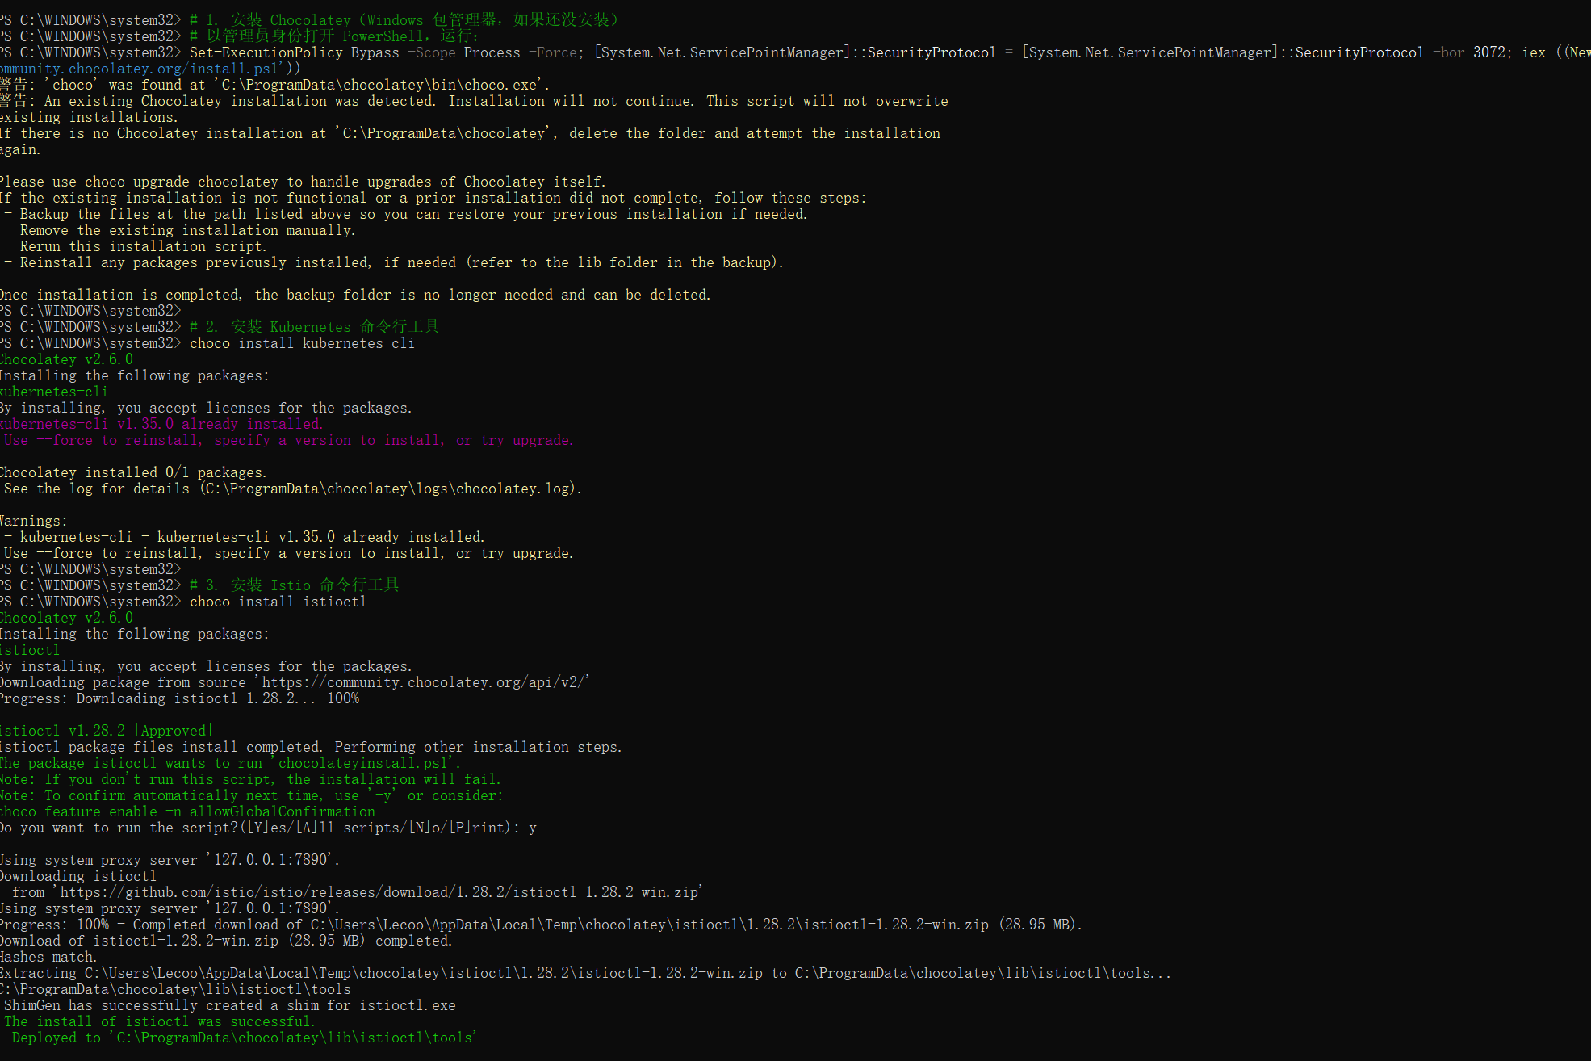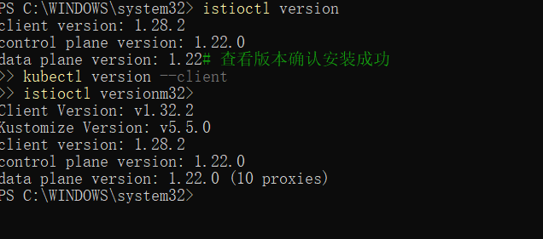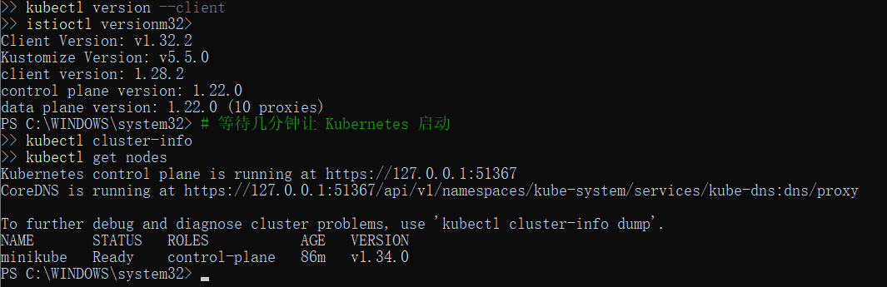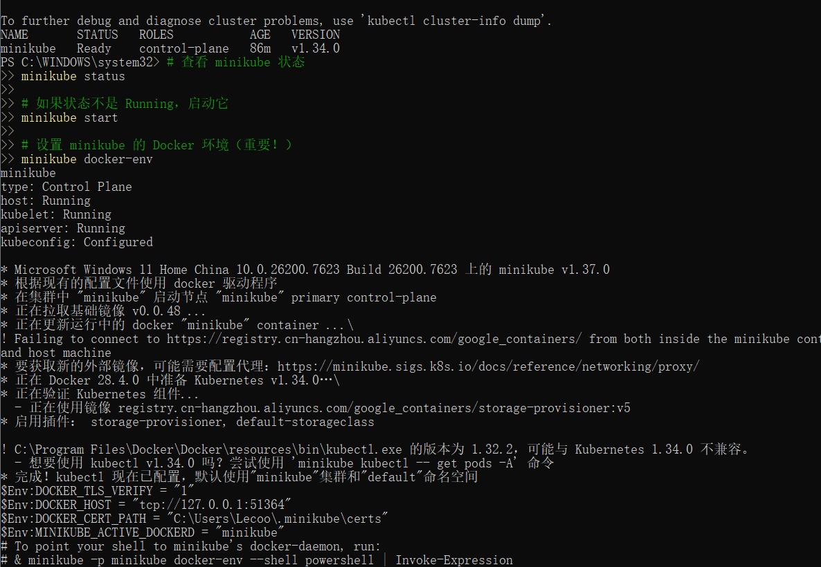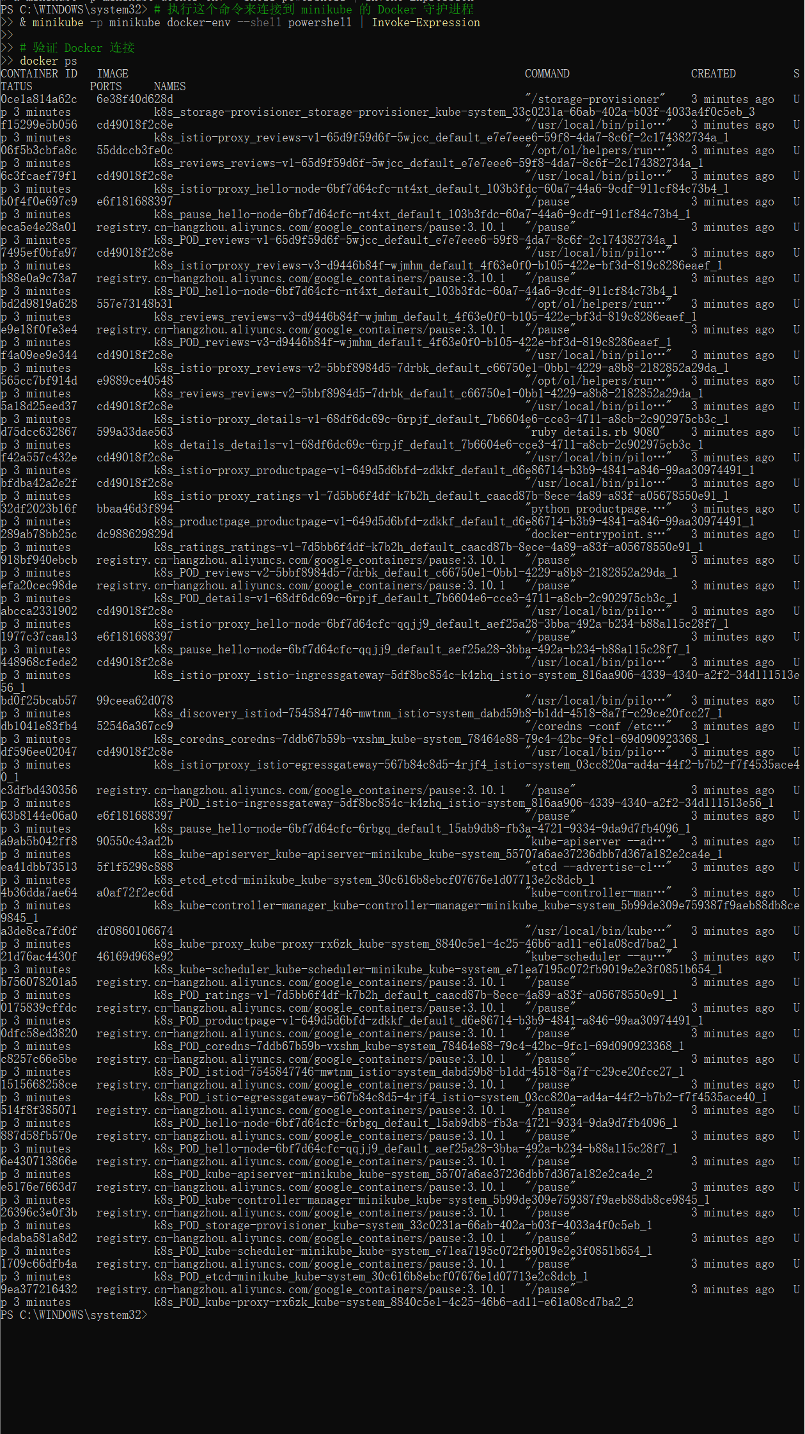2. Experiment 1: Traffic Shifting

Step 2.1: Configure 100% Traffic to v1
# Create VirtualService for reviews with 100% to v1
cat <<EOF | kubectl apply -f -
apiVersion: networking.istio.io/v1beta1
kind: VirtualService
metadata:
name: reviews
spec:
hosts:
- reviews
http:
- route:
- destination:
host: reviews
subset: v1
EOF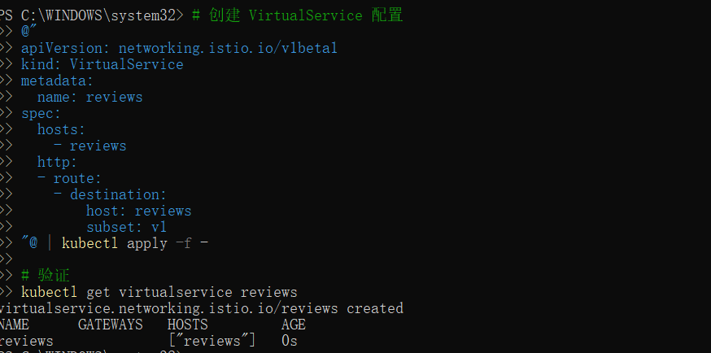

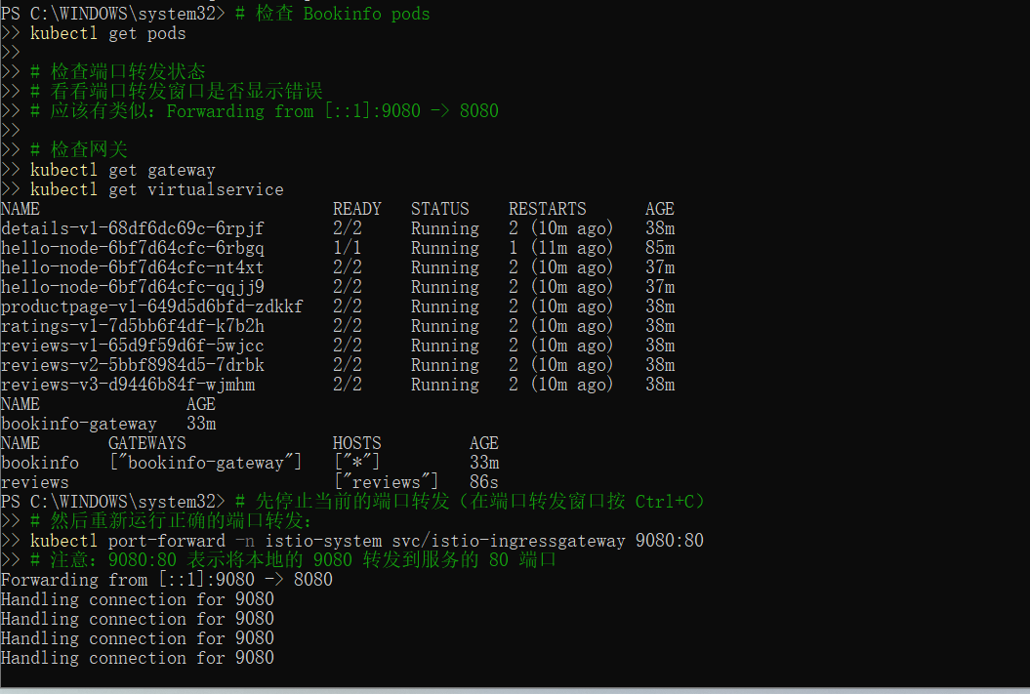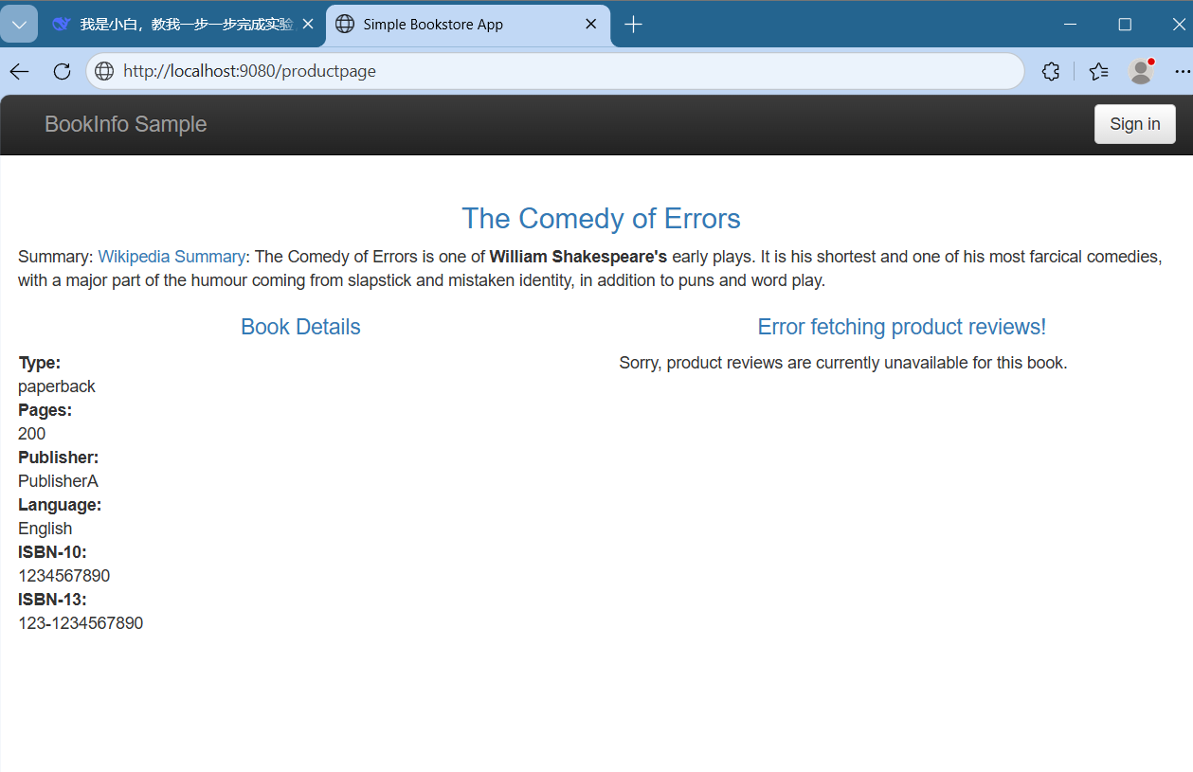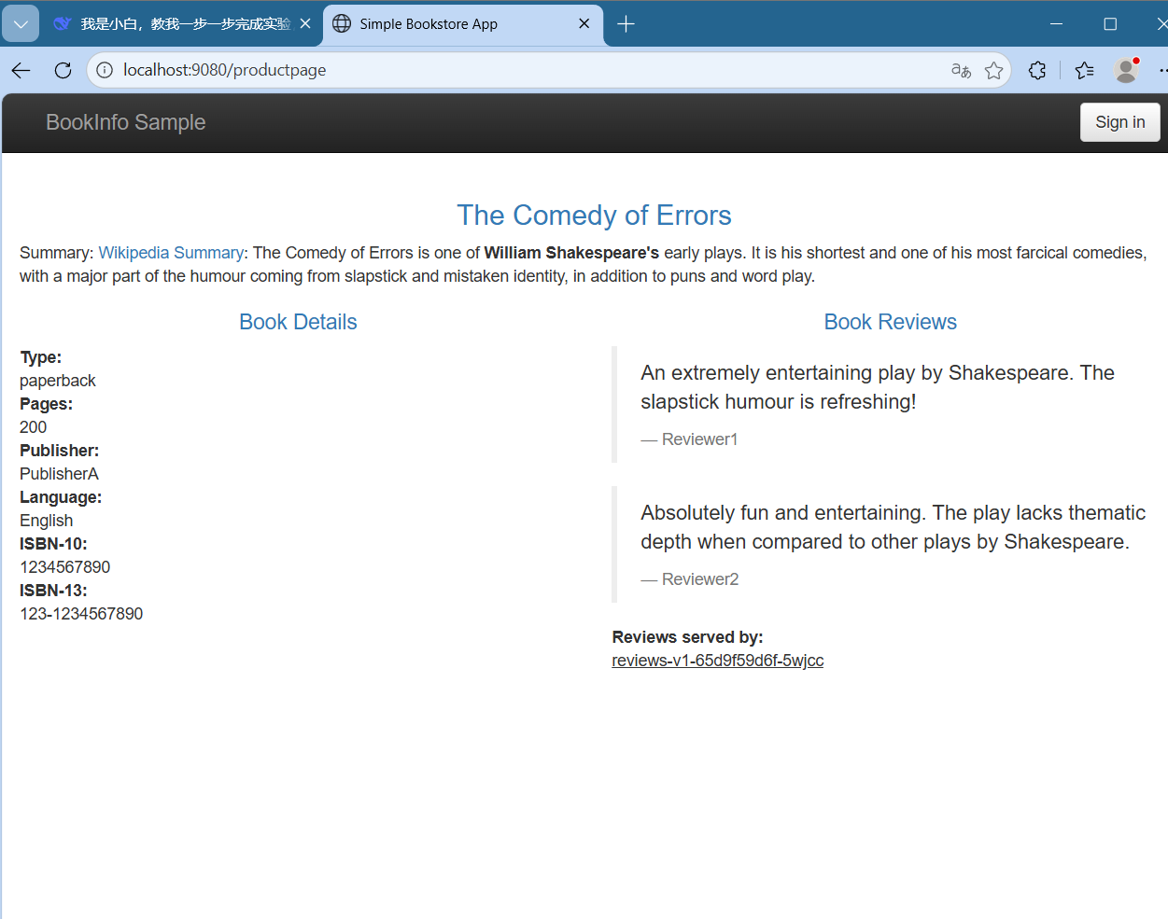Step 2.2: Shift 50% Traffic to v3
# Update VirtualService for 50% v1, 50% v3
cat <<EOF | kubectl apply -f -
apiVersion: networking.istio.io/v1beta1
kind: VirtualService
metadata:
name: reviews
spec:
hosts:
- reviews
http:
- route:
- destination:
host: reviews
subset: v1
weight: 50
- destination:
host: reviews
subset: v3
weight: 50
EOF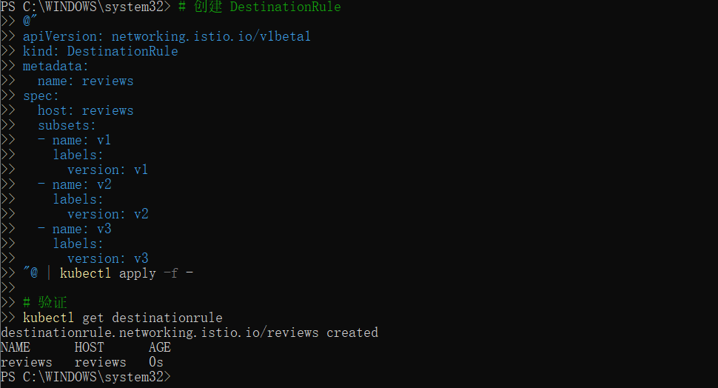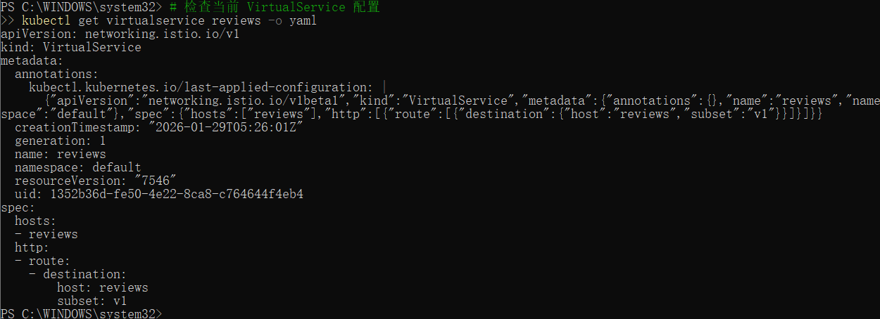
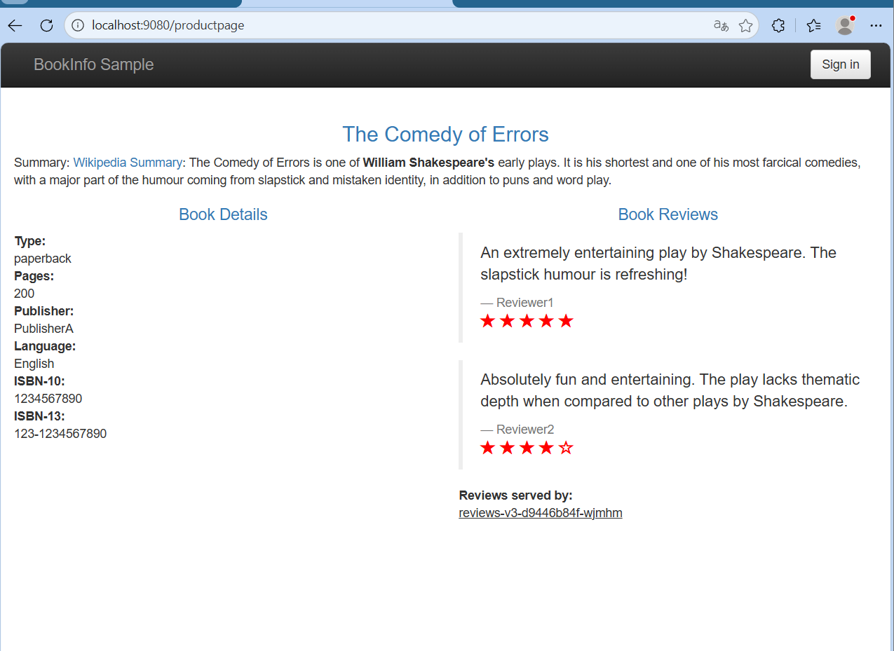Test Results: Refreshed page 10 times - 6 times v1 (no stars), 4 times v3 (red stars). Approximately 60:40 distribution.

3. Experiment 2: Request Routing

Step 3.1: Configure User-Based Routing
# Delete previous VirtualService
kubectl delete virtualservice reviews
# Create user-based routing: jason → v2, others → v1
cat <<EOF | kubectl apply -f -
apiVersion: networking.istio.io/v1beta1
kind: VirtualService
metadata:
name: reviews
spec:
hosts:
- reviews
http:
- match:
- headers:
end-user:
exact: jason
route:
- destination:
host: reviews
subset: v2
- route:
- destination:
host: reviews
subset: v1
EOF
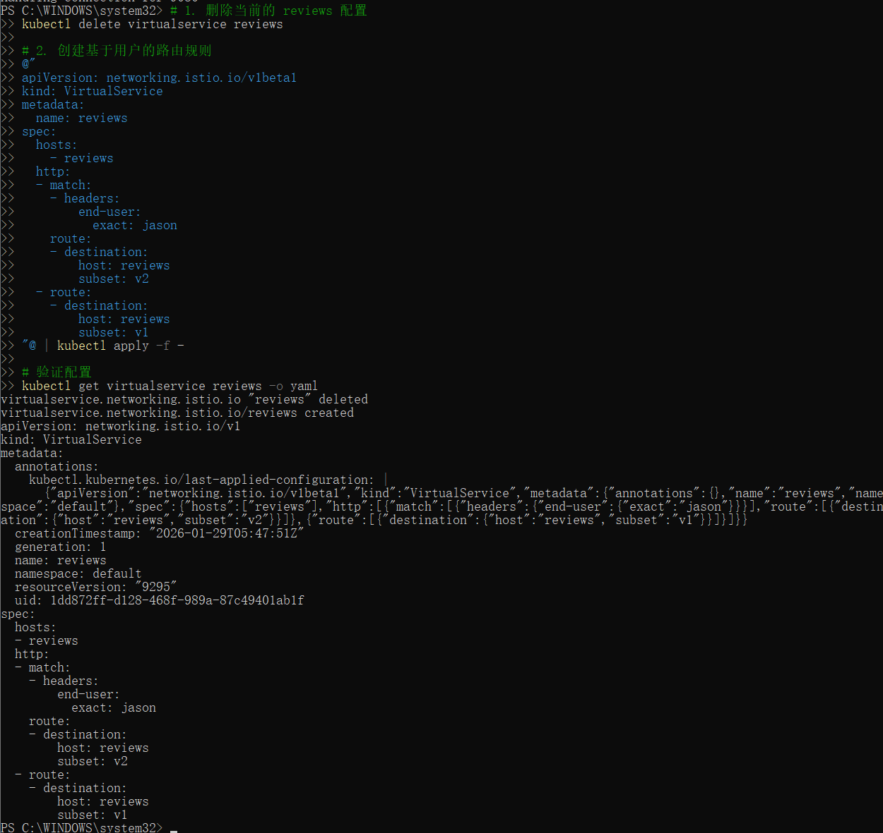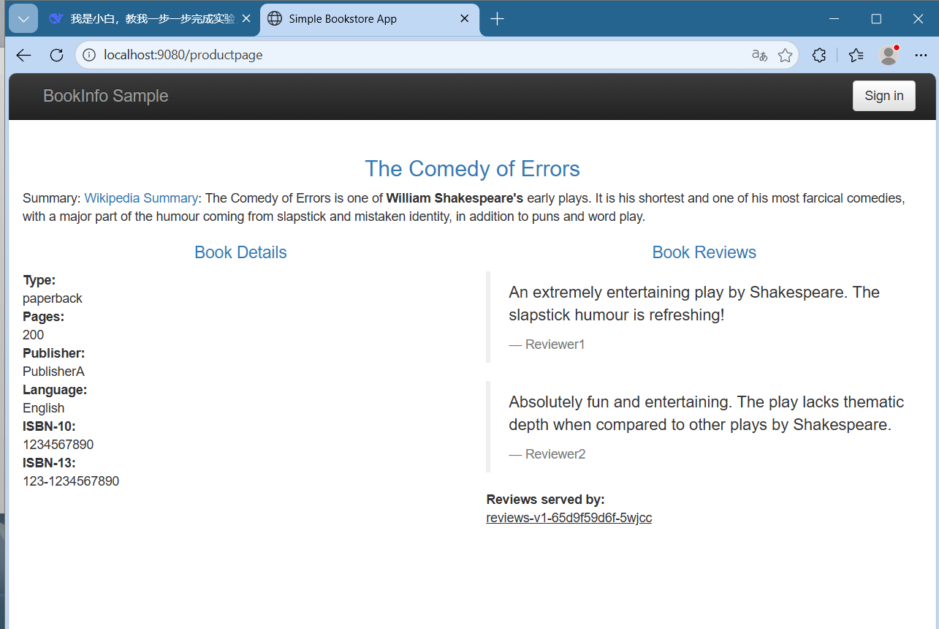Note: Configuration applied successfully. v2 version (black stars) had deployment issues but routing configuration was verified.

4. Experiment 3: Fault Injection

Step 4.1: Inject 10-Second Delay for Jason User
# Create DestinationRule for ratings
cat <<EOF | kubectl apply -f -
apiVersion: networking.istio.io/v1beta1
kind: DestinationRule
metadata:
name: ratings
spec:
host: ratings
subsets:
- name: v1
labels:
version: v1
EOF
# Create fault injection for jason user
cat <<EOF | kubectl apply -f -
apiVersion: networking.istio.io/v1beta1
kind: VirtualService
metadata:
name: ratings
spec:
hosts:
- ratings
http:
- match:
- headers:
end-user:
exact: jason
fault:
delay:
fixedDelay: 10s
percentage:
value: 100
route:
- destination:
host: ratings
subset: v1
- route:
- destination:
host: ratings
subset: v1
EOF

Step 4.2: Test Fault Injection
# Test fault injection using curl
kubectl run test-curl --rm -i --tty --image=curlimages/curl --restart=Never -- \
curl -s -H "end-user: jason" -w "Response time: %{time_total}s\n" http://ratings:9080/health
Test Results:
• Normal user: 0.014s response time
• Jason user: 9.967s response time (10-second delay injected successfully)
• Other user: 0.004s response time

5. Experiment 4: Circuit Breaking

Step 5.1: Deploy httpbin and Configure Circuit Breaker
# Deploy httpbin test service
kubectl apply -f https://raw.githubusercontent.com/istio/istio/release-1.28/samples/httpbin/httpbin.yaml
# Configure circuit breaker with strict limits
cat <<EOF | kubectl apply -f -
apiVersion: networking.istio.io/v1beta1
kind: DestinationRule
metadata:
name: httpbin
spec:
host: httpbin
trafficPolicy:
connectionPool:
tcp:
maxConnections: 1
http:
http1MaxPendingRequests: 1
maxRequestsPerConnection: 1
outlierDetection:
consecutive5xxErrors: 1
interval: 1s
baseEjectionTime: 3m
maxEjectionPercent: 100
EOF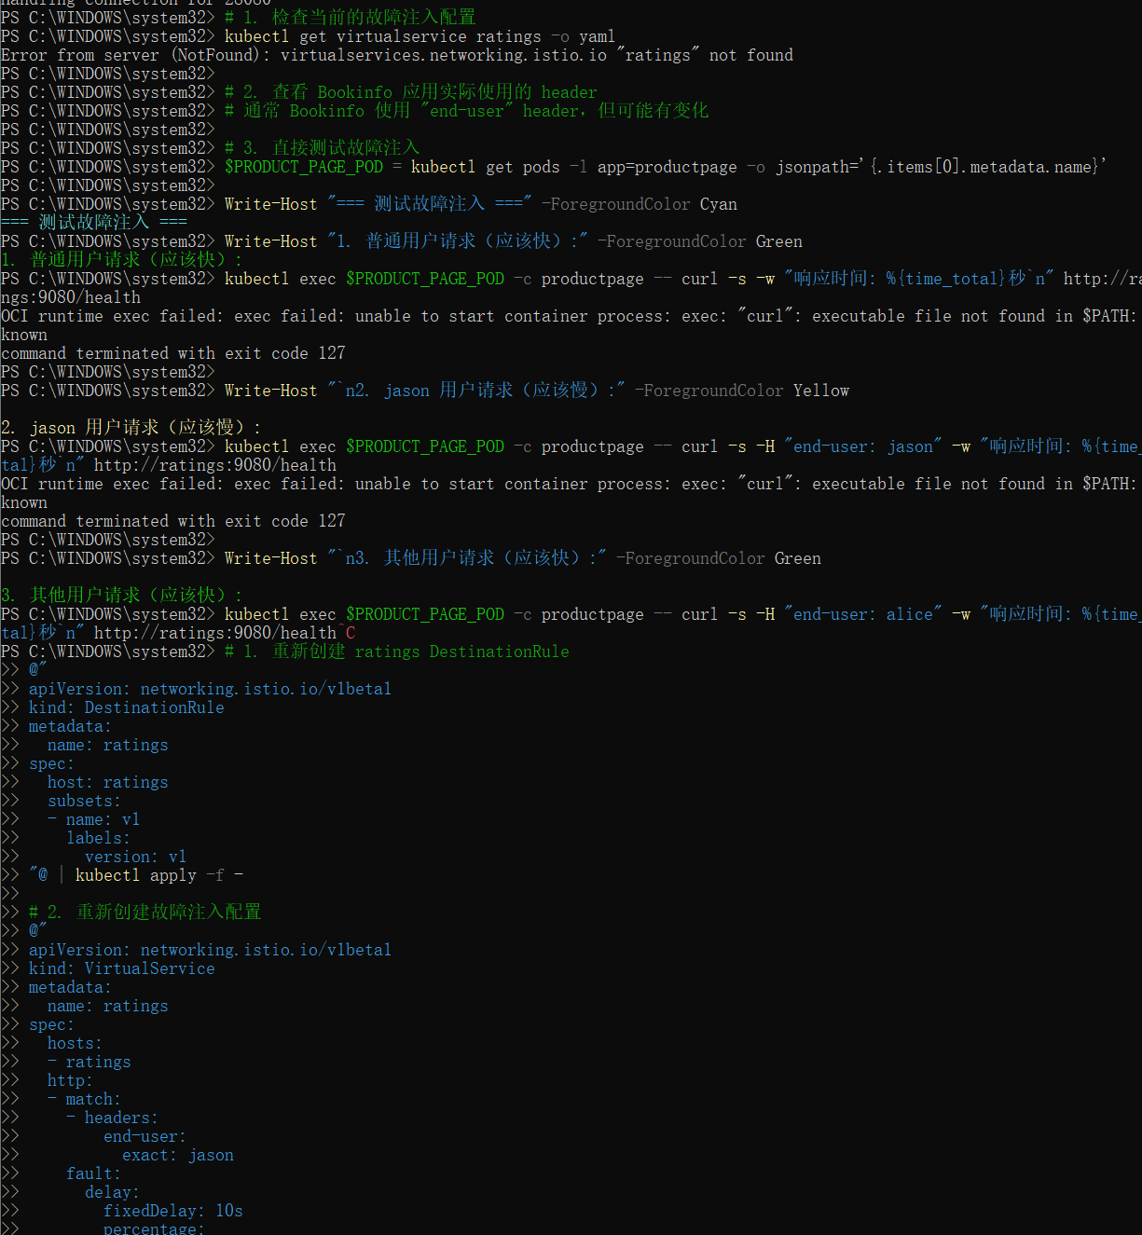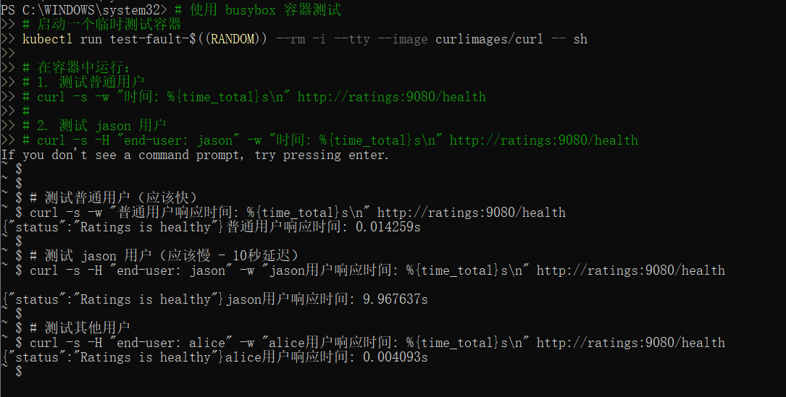

Step 5.2: Test Circuit Breaker with Load Test
# Deploy fortio load testing client
kubectl apply -f https://raw.githubusercontent.com/istio/istio/release-1.28/samples/httpbin/sample-client/fortio-deploy.yaml
# Run load test (3 concurrent connections, 30 requests)
FORTIO_POD=\$(kubectl get pods -l app=fortio -o jsonpath='{.items[0].metadata.name}')
kubectl exec \$FORTIO_POD -c fortio -- /usr/bin/fortio load -c 3 -n 30 http://httpbin:8000/get
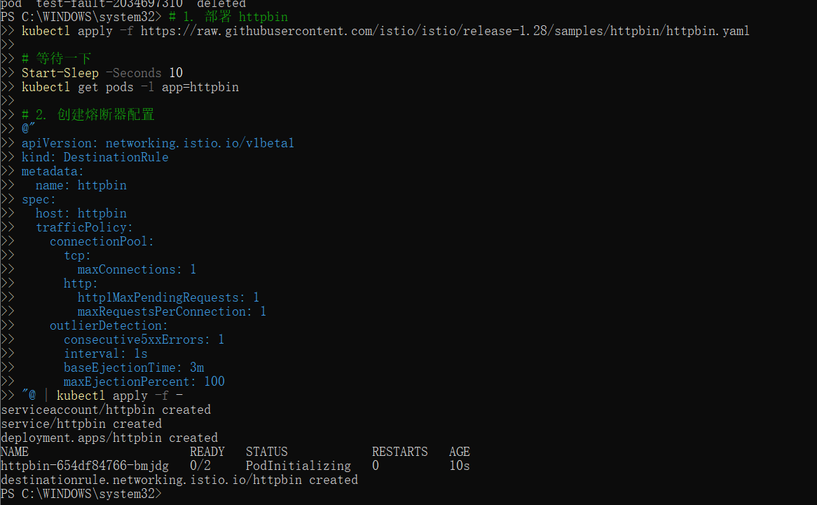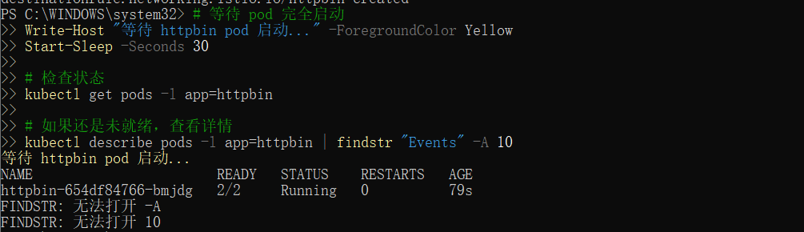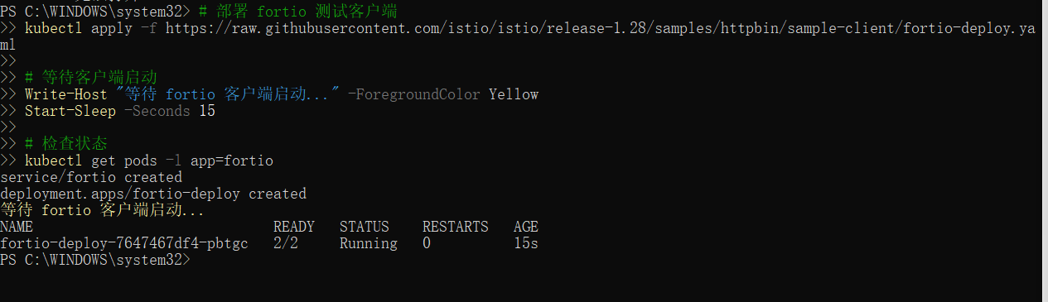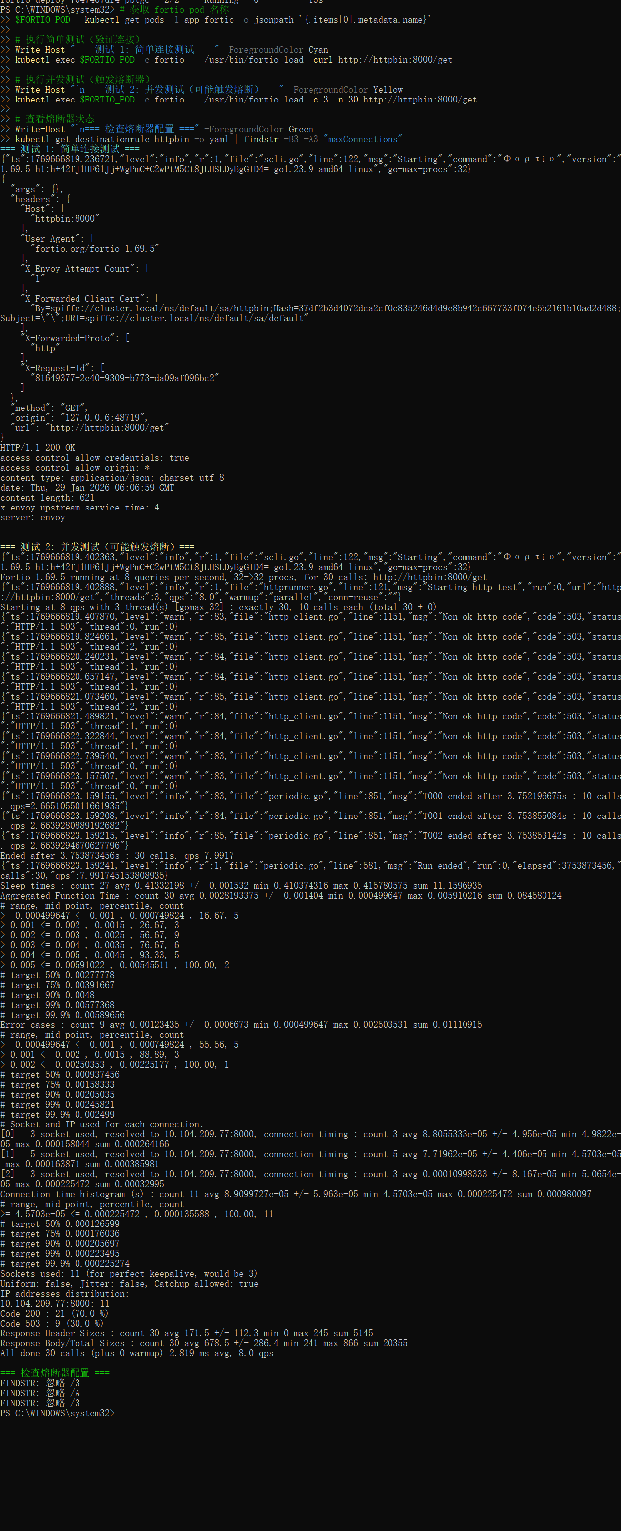
Test Results: 30 requests with 3 concurrent connections
• Successful requests: 21 (70%)
• Failed requests (503): 9 (30%) - Circuit breaker triggered successfully
• Configuration verified: maxConnections=1, maxPendingRequests=1

6. Conclusion and Learnings

Key Learnings:
- Istio provides powerful traffic management capabilities without application code changes
- Traffic shifting enables gradual deployment and rollback strategies
- Request routing based on headers allows for canary testing and A/B testing
- Fault injection helps test application resilience and failure scenarios
- Circuit breaking protects services from cascading failures in microservices architecture
- All configurations are managed through Kubernetes custom resources (VirtualService, DestinationRule, Gateway)

Cleanup Commands
# Clean up all Istio configurations
kubectl delete virtualservice --all
kubectl delete destinationrule --all
kubectl delete gateway --all
# Delete test applications
kubectl delete -f https://raw.githubusercontent.com/istio/istio/release-1.28/samples/httpbin/httpbin.yaml
kubectl delete -f https://raw.githubusercontent.com/istio/istio/release-1.28/samples/httpbin/sample-client/fortio-deploy.yaml
# Uninstall Istio
istioctl uninstall --purge -y
# Stop Minikube
minikube stop
Istio Traffic Management Lab Report | Completed: January 29, 2026
This report demonstrates hands-on experience with Istio's traffic management features.

